Project Proposal: Chat Go

A Hybrid TCP/UDP Real-Time Communication System

1. Introduction
Chat Go is a modern, high-definition desktop application designed to facilitate seamless real-time communication between multiple users over a local network (LAN) or the internet.
In an era where digital communication is paramount, Chat Go distinguishes itself by offering a hybrid networking architecture. It combines the reliability of TCP for secure text and file exchange with the low-latency performance of UDP for high-quality voice and video streaming. Built entirely using Python, Chat Go provides a robust, user-friendly interface that mimics top-tier messaging platforms, offering features such as group chats, encrypted messaging, and real-time media sharing.

2. Objectives
- To develop a scalable client-server architecture capable of handling multiple concurrent connections.
- To implement a Hybrid Protocol Stack (TCP & UDP) to optimize performance for different data types.
- To provide a secure environment with end-to-end encryption for text messages.
- To create an intuitive, HD-ready Graphical User Interface (GUI) using Tkinter.

3. Key Features & Backend Architecture
Chat Go leverages specific transport layer protocols to ensure the best experience for each specific feature.

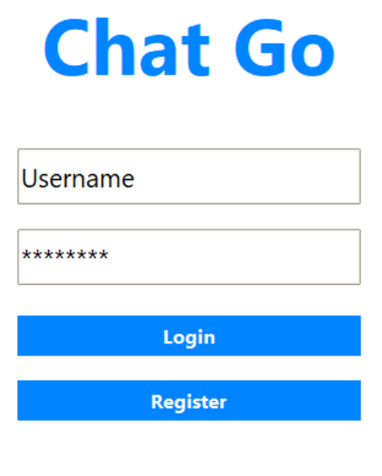
A. User Authentication & Presence (TCP)
- Feature: Users can register, login securely, and view real-time status updates (Online/Offline) of their friends.
- Backend Protocol: TCP (Transmission Control Protocol)
- Technical Detail: TCP is used here because authentication requires absolute reliability. A lost packet during login could prevent access. The system uses a persistent TCP connection to maintain a "Heartbeat," ensuring that when a user disconnects, their status is immediately updated to "Offline" for all friends.

B. One-on-One & Group Messaging (TCP)
- Feature: * Private Chat: Direct messaging between two users.
  - Group Chat: Users can create password-protected groups and join "Available Groups" listed on the server.
  - Encryption: Messages are obscured using a custom encryption algorithm before transmission.
- Backend Protocol: TCP
- Technical Detail: Text messages must arrive in the exact order they were sent and without corruption. TCP’s flow control and error-checking mechanisms ensure that no message is lost. The server acts as a relay, routing messages to specific socket objects based on the target username or group ID.
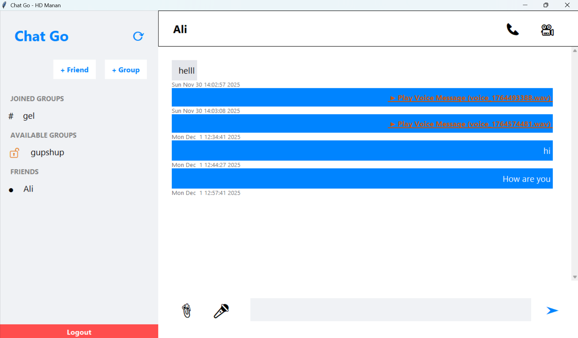

C. File & Voice Note Transfer (TCP)
- Feature: * Users can send Images (.png, .jpg), Documents, and recorded Audio Voice Notes (.wav).
  - Files are automatically downloaded to a dedicated downloads folder.
- Backend Protocol: TCP
- Technical Detail: File transfer requires data integrity. A corrupted byte in an image or executable renders the file useless. We utilize a large TCP buffer size (1MB - 2MB) to handle file chunks efficiently, converting binary data to Base64 strings for safe transmission over the JSON socket stream.

D. Real-Time Voice & Video Calling (UDP)
- Feature: * Video Call: Real-time camera streaming between users.
  - Voice Call: Low-latency audio conversations.
  - Group Calling: Multiple users can join a room and receive streams from the speaker.
- Backend Protocol: UDP (User Datagram Protocol)
- Technical Detail: * Why UDP? Unlike text, live video/audio is time-sensitive. If a video frame is lost, it is better to skip it and show the next one rather than pausing the call to wait for retransmission (which TCP does). UDP provides the necessary speed for smooth streaming.
- Implementation: The application captures frames using OpenCV and audio using PyAudio. These are compressed, serialized, and blasted over UDP packets. The server acts as a high-speed relay, forwarding these packets to the correct IP/Port of the recipient without performing deep inspection, ensuring minimal latency.
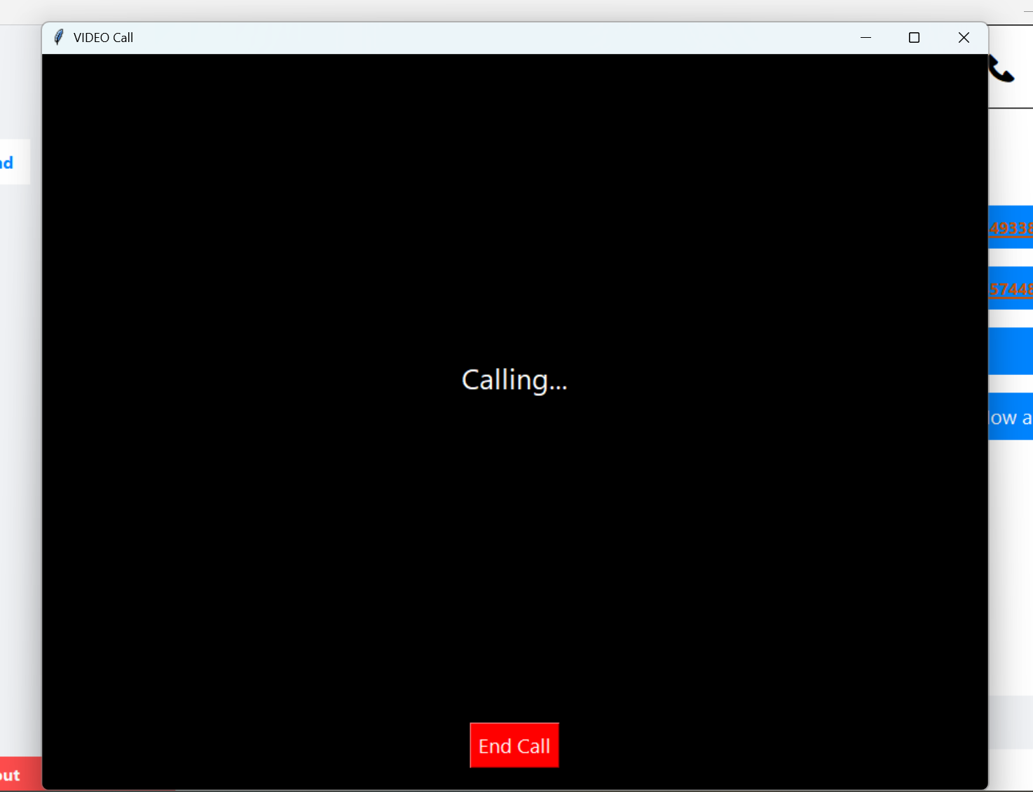

E. Modern Graphical User Interface (GUI)
- Feature: An HD (1280x720) interface with interactive hover effects, dynamic sidebars, and "Messenger-style" chat bubbles.
- Technical Detail: Built with Python’s tkinter and ttk libraries. The UI runs on the main thread, while all network operations (listening for messages, sending files, streaming video) run on separate background Threads to prevent the interface from freezing.

4. System Requirements
- Language: Python 3
- Libraries: socket (Networking), threading (Concurrency), sqlite3 (Database), tkinter (GUI), opencv-python (Video), pyaudio (Audio).
- Network: Wi-Fi or LAN connection required for multi-device communication.

5. Conclusion
Chat Go represents a comprehensive solution for network programming challenges. By intelligently separating data traffic—routing critical data through TCP and real-time streams through UDP—the application achieves professional-grade performance. It successfully demonstrates the practical application of socket programming, multi-threading, and database management in a cohesive software product.

